- Install the command line tool “SecureCRT”, and run SecureCRTPortable.exe.
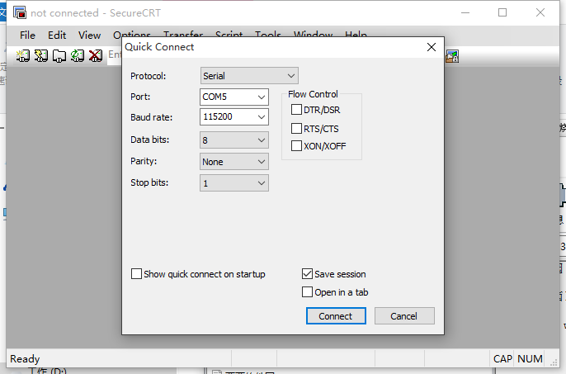

- Find and select the port number, computer management-->device manger-->COM LPT. Then back to the SecureCRT page, and click file to set a quick connect.
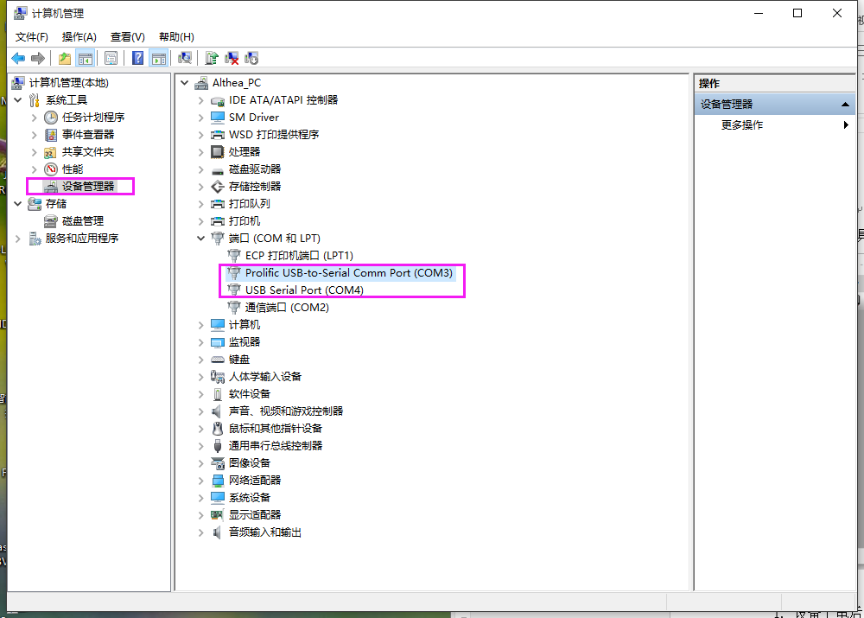

If the selection is right, and quick setting is right, the debug program will run like this.
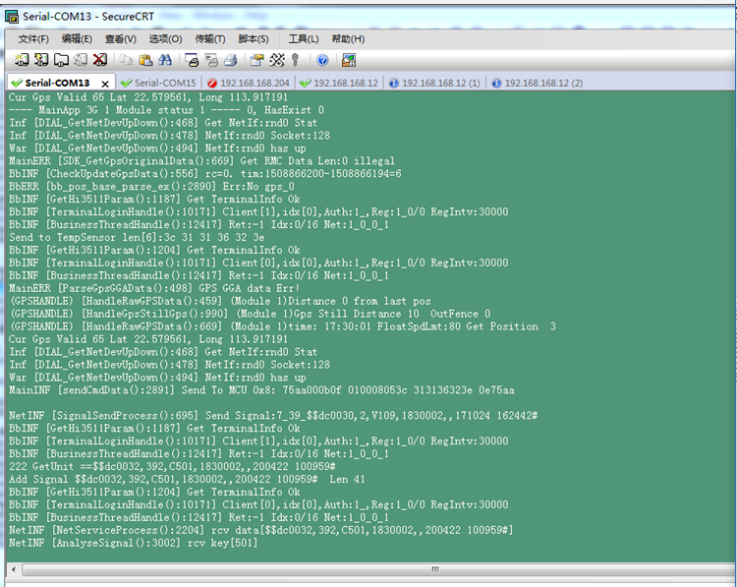
- Select Option, and then config the log settings like the follow picture.
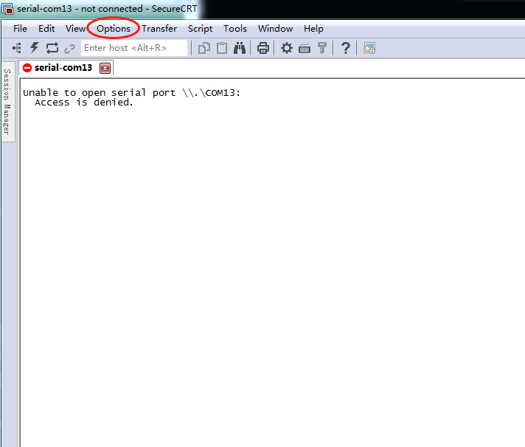
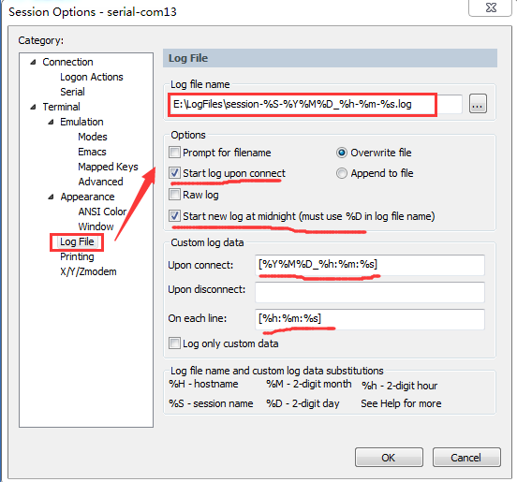

- After all settings, back to the program running page. It will save the logs auto. And you can get the log from the following path.
